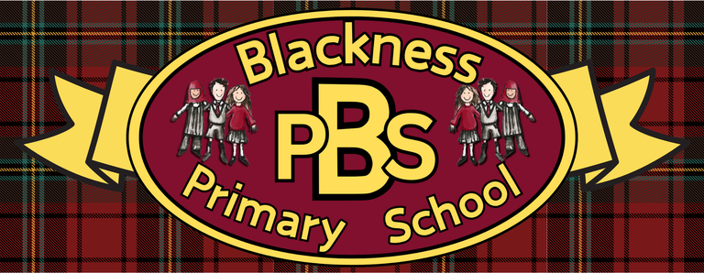 “Everyone Here Matters”

Allergy Aware Policy
Allergy is the most common chronic condition among children, affecting around two pupils in every Scottish classroom. 18% of all food allergy reactions and a quarter of first-time anaphylaxis episodes happening in schools. Our school is committed to keeping children with allergies safe, included, and fully able to participate in all aspects of school life. We adopt an allergy-aware (not blanket “allergen-free”) approach, focusing on education, clear communication, risk reduction and emergency preparedness across the whole school community, including catering, classroom practice, trips, clubs and events.
Although we recognise that it is impossible to guarantee, at Blackness Primary School we strive to be a Nut-Free school. This policy serves to set out all measures to reduce the risk to those children and adults who may suffer an (anaphylactic) reaction when exposed to nuts to which they are sensitive. The school aims to protect children who have allergies to nuts yet also help them, as they grow up, to take responsibility as to what foods they can eat.
Snacks and lunches
We do not allow nuts or nut products in school as part of snacks or lunches. Our Allergy Aware Policy means that the following items should not be brought into school:
• Packs of nuts
• Peanut butter sandwiches
• Nutella spread Sandwiches
• Fruit and cereal bars that contain nuts
• Chocolate bars or sweets that contain nuts
• Cakes made with nuts
• Items containing coconut
We work closely with the catering services at Tayside Contracts to ensure the meals provided do not contain nut products, or if they do, ensuring all staff and parents and children with a nut allergy are aware of these items. Most suppliers provide catering with nut-free products. However, we cannot guarantee that some items may state – may contain traces of nuts. Children are unable to bring in birthday cakes or homemade items as we cannot guarantee that they will not contain nuts and they do not comply with our helath promoting school stance.
While it cannot be guaranteed, children will be encouraged not to share food items in school with their peers.

Ready Respectful Safe
“Everyone Here Matters”

Allergies, Intolerances and Dietary Requirements
We recognise that children may have a range of allergies, intolerances and individual dietary requirements that need to be considered when planning and providing food. This includes, but is not limited to, cow’s milk/dairy allergy, lactose intolerance, wheat or gluten-related requirements, soya allergy, fish allergy, and shellfish allergies, including crustaceans and molluscs. We will also take account of any other individual allergies or intolerances identified by families or medical professionals. Where an allergy or intolerance has been identified, appropriate information should be shared with the setting so that suitable measures can be put in place to reduce the risk of exposure and ensure the child’s needs are appropriately supported. Tayside Contracts will provide a menu tailored to a child’s dietry requirements if required.
Allergies and intolerances should be distinguished from dietary, religious and cultural requirements. Families may request adaptations to meals for reasons including vegetarianism, veganism, halal requirements, cultural practices, personal preferences or other family dietary choices. These requirements will be discussed with families and, where appropriate, recorded separately from medically identified allergies or intolerances. This distinction helps ensure that staff have clear and accurate information about each child’s needs, while supporting families to communicate dietary requirements openly and ensuring that all children can be included safely and appropriately at mealtimes.

Cooking opportunities at school
As part of our Health and Wellbeing Curriculum there will be opportunities for all children to be involved in Food and Health topics which includes cooking and hygiene. We would like all children to be included and therefore, all ingredients will be carefully selected by staff to ensure that they do not contain the wording:
• Contains nuts
• May contain nuts
• Contains traces of nuts
• Is not suitable for nut allergy sufferers
Ingredients which suggest “may contain traces of nuts” will be allowed to be used in classroom activities, as there is a minimal risk of cross contamination If a child in a class has a particular aleergy/intolerance then this ingredient will not be used in this class.

Ready Respectful Safe
“Everyone Here Matters”

Treats and donations
Staff may wish to purchase snacks for the children to have in school as part of an earned reward. Again, these items will be carefully selected to ensure that they meet our policy expectations and the requirements of the pupils in their class. If for some reason, items do suggest that they could contain nuts, then children will be encouraged to take them home for consumption. On occasion we ask parents/carers to provide us with donations for tombolos etc. we ask that when handing in any food donations all effort must be made to ensure that they are free from allergens.
Health plans and emergency procedures
All children with anaphylaxis have an individual stepped care plan from the NHS which we will adhere to and follow if they display symptoms during school hours. These are kept with the child’s medication and/or Epi-Pen. Those pupils with an allergy ot intolerance have an ASP (Additional Support Plan) to mitigate any chance of then being exposed to their named allergen and that provides clarity on the process to follow if they are exposed. Most support staff are trained on using Epi-Pens and we will continue to ensure a refresh of the process is done on an annual basis so that all staff are able to spot symptoms and administer medication correctly.

Ready Respectful Safe

